Question Bank — Answers
23ACA10 — Artificial Intelligence
III B.Tech I Semester

UNIT I

PART-A (2 Marks)
1. Define Artificial Intelligence (AI).
Artificial Intelligence is the branch of computer science concerned with building systems that can perform tasks which normally require human intelligence, such as reasoning, learning, perception, and decision-making. It aims to create agents that act rationally to achieve goals in their environment.
2. What are the major foundations of AI?
AI draws on philosophy (reasoning and knowledge), mathematics (logic, probability, computation), economics (decision theory, utility), neuroscience (brain function), psychology (human cognition and behaviour), linguistics (natural language), and computer engineering (hardware to implement AI systems).
3. List any two applications of AI.
Two common applications are: (1) Autonomous vehicles, which use perception, planning, and control to drive without human input, and (2) Virtual assistants such as Siri or Alexa, which use natural language processing and speech recognition to interact with users.
4. What is an intelligent agent?
An intelligent agent is anything that perceives its environment through sensors and acts upon that environment through actuators to achieve specific goals. It maps a sequence of percepts to an action using an internal agent program.
5. Define rationality in the context of intelligent agents.
Rationality means an agent selects the action that maximizes its expected performance measure, given the percept sequence it has observed so far, its built-in knowledge, and the actions available to it. A rational agent need not be perfect, only the best possible given available information.
6. What is an agent environment?
The environment is everything external to the agent that it interacts with — the surroundings from which it receives percepts and on which its actions have an effect. Examples include the physical world for a robot or a chessboard for a game-playing program.
7. Differentiate between an agent and its environment.
An agent is the decision-making entity that perceives and acts, whereas the environment is the external system the agent operates within. The agent has sensors and actuators and internal decision logic; the environment supplies percepts and receives the agent's actions, evolving independently of the agent's internal reasoning.
8. What is meant by the nature of an environment?
The nature of an environment refers to its defining properties — such as being fully or partially observable, deterministic or stochastic, episodic or sequential, static or dynamic, discrete or continuous, and single-agent or multi-agent — which together determine the complexity of the agent design needed.
9. List the basic components of an intelligent agent.
The basic components are sensors (to perceive the environment), actuators (to act on the environment), a performance measure (to evaluate success), and an agent program (the internal function that maps percepts to actions, often using knowledge of the environment).
10. What is a rational agent?
A rational agent is one that, for every possible percept sequence, selects an action expected to maximize its performance measure based on the evidence provided by the percept sequence and whatever built-in knowledge it has, acting to achieve the best possible outcome.

PART-B (10 Marks)
1. Explain the concept of Artificial Intelligence and discuss its major foundations.
Artificial Intelligence (AI) is the study and design of computational agents that act intelligently — that is, agents capable of perceiving their environment, reasoning about it, learning from experience, and taking actions to achieve defined goals. AI systems range from simple rule-based programs to complex learning systems such as deep neural networks. The central goal of AI is to build systems whose behaviour matches or exceeds human performance on cognitive tasks like problem-solving, language understanding, and perception.
The foundations of AI are multidisciplinary:
- Philosophy — contributed ideas of logic, reasoning, mind-body relationships, and the origins of knowledge.
- Mathematics — provided formal tools such as logic, probability theory, statistics, and computation/complexity theory that underlie algorithms.
- Economics — introduced decision theory and utility theory, used for designing agents that make rational choices under uncertainty.
- Neuroscience — the study of the human brain inspired computational models such as artificial neural networks.
- Psychology — cognitive psychology's models of human thought and behaviour informed how AI systems represent knowledge and make decisions.
- Linguistics — contributed to natural language processing by studying the structure and meaning of language.
- Computer Engineering — supplied the hardware (processors, memory, parallel computation) necessary to build and run AI systems efficiently.
Together, these foundations give AI both its theoretical grounding and its practical toolkit, enabling systems to reason logically, learn statistically, and act rationally in complex environments.
2. Describe the history and evolution of Artificial Intelligence.
The intellectual roots of AI trace back to classical logic and philosophy, but AI as a formal discipline began in 1956 at the Dartmouth Conference, where the term 'Artificial Intelligence' was coined by John McCarthy. Early AI (1950s–60s) focused on symbolic reasoning and search, producing programs like the Logic Theorist and General Problem Solver, and generated great optimism about achieving human-level intelligence quickly.
This was followed by the first 'AI winter' (1970s) when early approaches failed to scale to real-world problems due to limited computing power and combinatorial explosion in search. The 1980s saw a resurgence with expert systems (e.g., MYCIN, DENDRAL) that encoded human expert knowledge as rules, leading to commercial success, but this too slowed by the late 1980s as expert systems proved brittle and expensive to maintain (second AI winter).
From the 1990s onward, AI shifted toward probabilistic and data-driven methods: machine learning, Bayesian networks, and statistical NLP. The 2000s–2010s brought the deep learning revolution, driven by large datasets, GPU computing, and improved neural network architectures, producing breakthroughs in image recognition (CNNs), game playing (AlphaGo), and language (transformers). Today's AI includes large language models and multimodal systems that perform close to or beyond human level on many benchmark tasks, while research continues on reasoning, safety, and generalization.
3. Explain the state of the art in Artificial Intelligence with suitable examples.
The state of the art in AI spans several domains, each with mature real-world systems:
- Game playing: AlphaGo and AlphaZero defeated world champions in Go and Chess using deep reinforcement learning combined with tree search, surpassing decades of hand-crafted heuristics.
- Computer vision: Convolutional neural networks and vision transformers now achieve human-competitive accuracy in image classification, object detection, and medical image diagnosis.
- Natural language processing: Large language models (transformer-based) can translate languages, summarize documents, answer questions, and generate coherent text, powering assistants and chatbots.
- Autonomous vehicles: Self-driving systems integrate perception, localization, and planning to navigate real traffic with limited human intervention.
- Robotics: Robots use reinforcement learning and sensor fusion to perform manipulation, warehouse logistics, and locomotion tasks in unstructured environments.
- Healthcare: AI models assist in diagnosing diseases from scans, predicting patient risk, and accelerating drug discovery through molecular modelling.
These examples show that current AI systems are highly capable within specific, well-defined tasks (narrow AI) but still lack the general, flexible reasoning of human intelligence — an active area of ongoing research.
4. Explain the concept of intelligent agents and their interaction with environments.
An intelligent agent is any entity that perceives its environment through sensors and acts upon it through actuators. Formally, an agent's behaviour is described by an agent function that maps every possible percept sequence to an action; this function is implemented internally by an agent program running on some physical architecture (hardware or software).
The interaction between agent and environment forms a continuous perception-action loop: the environment presents a state, the agent senses it as a percept, its agent program processes the percept (possibly combined with internal memory of past percepts) to decide an action, and this action is executed on the environment through actuators, changing the environment's state and producing new percepts. This cycle repeats indefinitely.
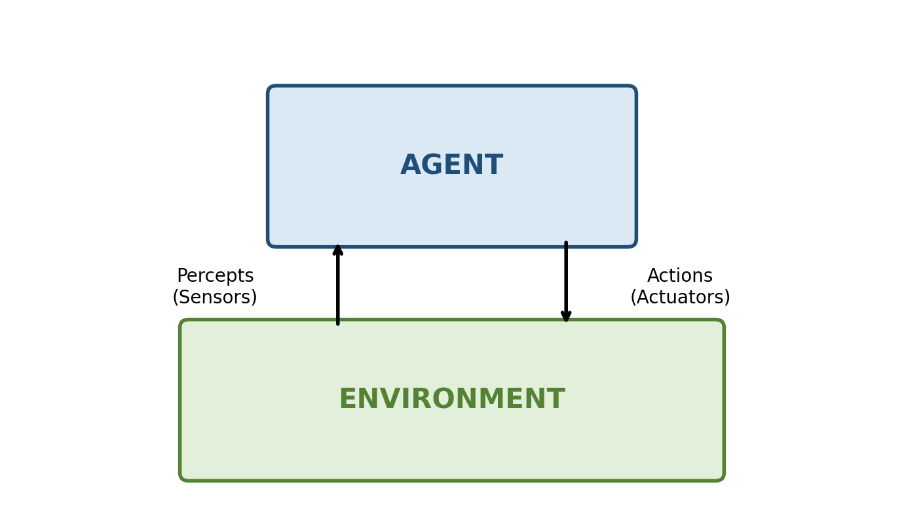
Fig 4.1: Agent–Environment interaction loop
For example, a vacuum-cleaning robot senses dirt and obstacles (percepts) via its sensors, decides whether to move, turn, or suck dirt (action) via its agent program, and executes this using its wheels and vacuum motor (actuators). The success of this interaction is judged using a performance measure, such as the amount of dirt cleaned per unit time. A well-designed agent aims to choose actions that maximize this measure given the percepts received.
5. Discuss the concept of rationality and explain the behaviour of a rational agent.
Rationality is the property of an agent that always selects the action expected to maximize its performance measure, given the percept sequence observed so far, the agent's built-in knowledge, and the actions available to it. Rationality is distinct from omniscience or perfection: a rational agent can still make what turns out to be a poor decision if the environment provides misleading or incomplete information, because rationality is judged based on what could reasonably be expected given the available evidence at decision time, not the actual outcome.
Four factors determine an agent's rationality at any given moment:
- The performance measure that defines the criterion of success.
- The agent's prior knowledge of the environment.
- The actions the agent is capable of performing.
- The agent's percept sequence up to that moment.
A rational agent behaves by continuously selecting the action that is expected to yield the best outcome according to its performance measure, using whatever information it currently has. For instance, a rational self-driving car chooses to brake when its sensors detect an obstacle, because braking maximizes the performance measure of passenger safety given the current percept, even though the specific outcome (whether a collision actually occurs) cannot be guaranteed in advance. Rational behaviour also includes information-gathering and learning: a rational agent explores its environment and updates its knowledge when doing so improves its future decisions, rather than acting solely on reflex.
6. Explain different types and characteristics of agent environments.
Environments are classified along several dimensions that determine the difficulty of designing a suitable agent:
- Fully Observable vs Partially Observable: In a fully observable environment, the agent's sensors give complete access to the relevant state at each point (e.g., chess). In a partially observable environment, sensors give incomplete or noisy information (e.g., driving in fog).
- Deterministic vs Stochastic: In a deterministic environment, the next state is completely determined by the current state and the agent's action (e.g., a puzzle game). In a stochastic environment, outcomes involve randomness or uncertainty (e.g., weather-dependent tasks).
- Episodic vs Sequential: In episodic environments, each action-decision episode is independent of previous ones (e.g., image classification). In sequential environments, current decisions affect future ones (e.g., chess, driving).
- Static vs Dynamic: A static environment does not change while the agent deliberates (e.g., crossword puzzle). A dynamic environment can change during deliberation (e.g., real-time strategy games).
- Discrete vs Continuous: Discrete environments have a finite number of distinct states/actions/percepts (e.g., chess), while continuous environments have infinitely many possible values (e.g., robot arm movement).
- Single-agent vs Multi-agent: A single-agent environment has only one decision-making entity (e.g., solving a maze). A multi-agent environment involves other agents that may cooperate or compete (e.g., multiplayer games).
These characteristics jointly define the 'nature' of an environment. The hardest environments to design agents for are partially observable, stochastic, sequential, dynamic, continuous, and multi-agent — such as real-world autonomous driving — because they demand memory, probabilistic reasoning, planning, and real-time adaptation, unlike simple environments such as tic-tac-toe.
7. Describe the structure of an intelligent agent with a suitable example.
The structure of an intelligent agent consists of an architecture (the physical or software platform, such as a computer or robot body with sensors and actuators) combined with an agent program (the algorithm that implements the agent function, mapping percepts to actions). The relationship is expressed as: Agent = Architecture + Program.
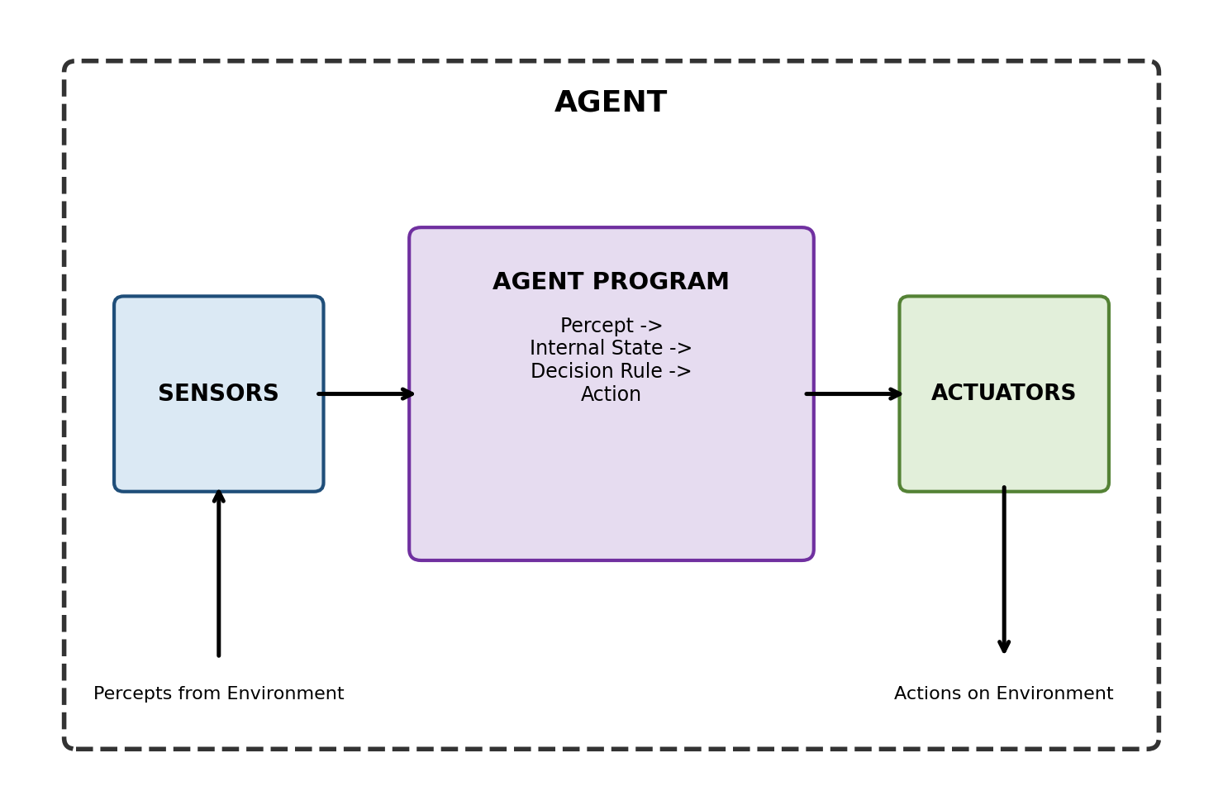
Fig 7.1: Structure of an intelligent agent
The agent program typically operates as follows: sensors capture percepts from the environment; the program processes these percepts, optionally maintaining an internal state that records relevant history; it applies decision rules (which may be simple condition-action rules, a search/planning process, or a learned model) to select the best action given the performance measure and goals; and finally, actuators execute the chosen action on the environment.
For example, in a simple thermostat agent, the sensor is a temperature sensor, the agent program is a rule such as 'if temperature < set point, turn on heater; else turn off,' and the actuator is the heater switch. More complex agents, such as a self-driving car, replace the simple rule with layers of perception, planning, and control algorithms, but the same architecture-plus-program structure applies.
8. Analyze how the environment influences the design of an intelligent agent.
The characteristics of an environment directly determine what capabilities an agent design must include, since a simple agent design that works well in one type of environment can fail badly in another:
- Observability: If an environment is partially observable, the agent must maintain an internal state or memory to track unseen aspects of the world; fully observable environments allow simpler reflex-based designs without memory.
- Determinism: Stochastic environments require the agent to reason probabilistically and plan for multiple possible outcomes (e.g., using expected utility), whereas deterministic environments permit simpler, single-outcome planning.
- Sequentiality: Sequential environments require agents capable of looking ahead and planning over multiple future steps, since present actions affect future states; episodic environments allow the agent to consider each decision independently.
- Dynamics: Dynamic environments demand real-time or continuous decision-making, since the environment may change while the agent thinks; static environments permit unlimited deliberation time.
- Discreteness: Continuous environments often require the agent to use numerical optimization or continuous control techniques rather than simple discrete rule lookups.
- Number of agents: Multi-agent environments require the agent to model other agents' behaviour (cooperative or adversarial), often using game-theoretic reasoning, unlike single-agent environments.
For example, a simple reflex agent suffices for a fully observable, deterministic, static, discrete environment such as tic-tac-toe. However, a self-driving car operating in a partially observable, stochastic, sequential, dynamic, continuous, multi-agent real-world environment requires a far more sophisticated design: it needs perception with uncertainty estimation, predictive models of other drivers, continuous control, and real-time re-planning. Thus, environment analysis is the first and most critical step in agent design, since it dictates the minimum sophistication the agent program must have to behave rationally.
9. Explain the evolution of AI from its foundations to modern applications.
AI's evolution can be traced as a progression from philosophical and mathematical foundations to today's data-driven applications. It began with foundational ideas from logic (Aristotle, Boole) and computation theory (Turing's formalization of computable functions and the Turing Test as a criterion for machine intelligence), which established that reasoning and intelligence could, in principle, be mechanized.
These ideas matured into the formal field of AI at the 1956 Dartmouth Conference, followed by symbolic AI approaches (1950s–70s) using logic-based search and knowledge representation to solve puzzles and theorem-proving tasks. The 1980s expert-systems era translated foundational knowledge-representation techniques into practical rule-based industry applications such as medical diagnosis and configuration systems, showing AI's first large-scale commercial value.
From the 1990s, the foundations in probability and statistics (drawn from mathematics) enabled a shift to machine learning, where systems learned patterns from data instead of relying purely on hand-coded rules — producing applications like spam filters and recommendation systems. The neuroscience-inspired foundation of artificial neural networks, combined with increased computing power (a computer-engineering contribution) and large datasets, then enabled the deep learning revolution of the 2010s, producing modern applications such as image recognition, speech assistants, autonomous vehicles, and large language models.
This shows a clear evolutionary arc: philosophical questions about intelligence led to mathematical formalization, which led to engineered symbolic systems, which were eventually surpassed by data-driven statistical learning systems — with each stage building on, rather than discarding, the foundational disciplines of AI.
10. Design a suitable intelligent-agent model for a real-world application and explain its components.
Consider designing an intelligent agent for an automated food-delivery robot operating on a university campus. This is a good example because it involves realistic complexity: partial observability (limited camera/sensor range), stochastic elements (unpredictable pedestrians), sequential decision-making (route planning over time), a dynamic environment (moving people and vehicles), and continuous state/action spaces (position, speed, steering).
PEAS description (Performance measure, Environment, Actuators, Sensors):
- Performance measure: Successful, timely, damage-free delivery; safety (avoiding collisions); energy efficiency; customer satisfaction.
- Environment: Campus pathways, buildings, pedestrians, other vehicles, weather conditions, delivery points.
- Actuators: Wheels/motors for movement, steering mechanism, a compartment-locking mechanism to secure/release the food, and a display or speaker for communicating with recipients.
- Sensors: Cameras, GPS module, ultrasonic/LiDAR distance sensors for obstacle detection, and a compartment-status sensor.
Fig 10.1: Structure applied to the delivery-robot agent
Agent program design: The robot uses a model-based, goal-based agent architecture rather than a simple reflex design, because the environment is partially observable and sequential. It maintains an internal state estimating its position and the surrounding obstacles (updated using sensor fusion from GPS and cameras), models how the environment evolves (e.g., predicting pedestrian movement), and uses this model together with a goal (reach the delivery location) to plan a path. A path-planning algorithm (e.g., A* or a learned policy) selects the next move, and a low-level controller converts this into actuator commands (speed and steering).
The robot continuously loops through: sense (via cameras/LiDAR/GPS) -> update internal state and world model -> plan/decide next action toward the goal, factoring in the performance measure (safety over speed) -> act via motors/steering -> repeat, while also using a utility-based component to break ties between multiple safe paths in favour of the fastest or most fuel-efficient one. This model-based, goal-and-utility-driven design is necessary because a simple reflex agent (react only to the current percept) would fail to navigate safely and efficiently in such a dynamic, partially observable campus environment.

UNIT II

PART-A (2 Marks)
1. What is a problem-solving agent?
A problem-solving agent is a goal-based agent that decides what to do by first formulating a goal and a problem (initial state, actions, goal test, path cost), and then searching for a sequence of actions that leads from the initial state to a goal state before executing that sequence.
2. What is meant by a search problem?
A search problem is a formal representation consisting of a state space, an initial state, a set of possible actions with a transition model, a goal test to check if a state is a goal, and a path cost function that assigns a cost to any sequence of actions, used to find an optimal or feasible solution path.
3. Define uninformed search.
Uninformed (blind) search refers to search strategies that have no additional information about the distance or cost from the current state to the goal beyond what is given in the problem definition. They explore the search space systematically, generating successors and testing for goals without any domain-specific guidance.
4. Give two examples of uninformed search strategies.
Two common uninformed search strategies are Breadth-First Search (BFS), which expands the shallowest unexpanded node first, and Depth-First Search (DFS), which expands the deepest unexpanded node first. Other examples include Uniform-Cost Search and Iterative Deepening Search.
5. What is informed search?
Informed (heuristic) search uses problem-specific knowledge, in the form of a heuristic function, to estimate how close a given state is to the goal, allowing it to guide the search toward more promising paths and typically find solutions more efficiently than uninformed search.
6. Define a heuristic function.
A heuristic function h(n) is a function that estimates the cost of the cheapest path from a given node n to a goal state, using domain-specific knowledge. It provides guidance to informed search algorithms such as Greedy Best-First Search and A*, without guaranteeing the estimate is exact.
7. What is local search?
Local search algorithms operate by starting from a single current state and moving to neighboring states, typically without maintaining a search tree or remembering the path taken. They are used for optimization problems where the goal is to find the best state according to an objective function, such as in Hill-Climbing or Simulated Annealing.
8. What is meant by nondeterministic action?
A nondeterministic action is one whose outcome cannot be fully predicted in advance because the environment may respond with more than one possible resulting state for the same action, such as a robot wheel slipping. Agents in such environments must plan for contingencies rather than a single fixed action sequence.
9. What is searching with partial observations?
Searching with partial observations occurs when the agent cannot directly determine its exact current state because its sensors provide incomplete information. The agent must reason over a belief state — a set of possible actual states consistent with its percepts — and search over these belief states rather than single states.
10. What is an online search agent?
An online search agent interleaves computation and action: it selects and executes an action, observes the resulting percept, and then decides the next action, rather than computing a complete solution before acting. This is necessary in unknown, dynamic, or nondeterministic environments where the agent cannot fully plan in advance.

PART-B (10 Marks)
1. Explain the architecture and working of a problem-solving agent with a suitable example.
A problem-solving agent is a type of goal-based agent that achieves its objectives by explicitly formulating a goal, representing the task as a well-defined problem, and searching for a sequence of actions that reaches the goal before executing that sequence in the real environment. It is suitable for environments that are static, fully observable, discrete, and deterministic enough for the agent to plan its full course of action in advance.
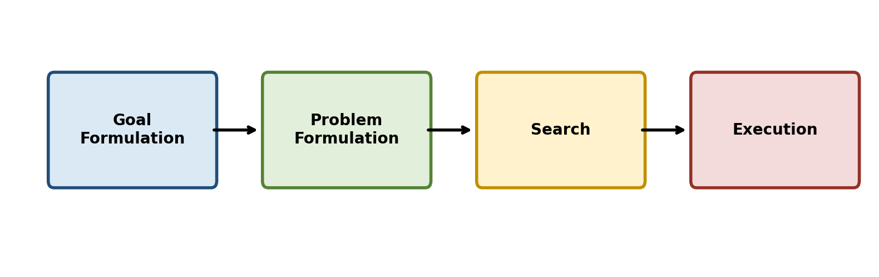
Fig 1.1: Four phases of a problem-solving agent
The agent's working proceeds through four phases: (1) Goal Formulation, where the agent decides which condition(s) it wants to achieve, based on the current situation and its performance measure; (2) Problem Formulation, where the agent decides what states and actions to consider, defining the initial state, action set, transition model, goal test, and path cost; (3) Search, where the agent uses a search algorithm to explore the state space and find a sequence of actions (a solution) that leads from the initial state to a goal state; and (4) Execution, where the agent carries out the action sequence in the real world, assuming the environment is predictable enough for open-loop execution.
For example, consider a route-finding agent for a delivery driver in a city: the goal is 'reach the destination address.' The problem formulation defines the initial state (current location), actions (drive to an adjacent intersection), transition model (which intersection is reached), goal test (is this the destination?), and path cost (distance or time). The agent searches the road-network graph to find the shortest or fastest route, and then executes this route by actually driving it, turn by turn.
2. Explain the process of searching for solutions to a problem.
Searching for a solution means systematically exploring the state space defined by a problem to find a sequence of actions from the initial state to a goal state. This is done by building a search tree, where the root is the initial state, and each node's children are the states reachable by applying legal actions to that node.
The general search process is: (1) Initialize the frontier (the set of nodes generated but not yet expanded) with the initial state. (2) Loop: if the frontier is empty, return failure (no solution). Otherwise, choose a node from the frontier to expand, according to the search strategy. (3) If the chosen node's state passes the goal test, return the corresponding solution (the sequence of actions from root to this node). (4) Otherwise, expand the node by generating its successor states via the transition model, add newly generated nodes to the frontier, and add the expanded node to the explored set to avoid re-expanding the same state (in graph search). (5) Repeat the loop.
The choice of which node to pick from the frontier at each step defines the search strategy (e.g., FIFO order gives Breadth-First Search, LIFO order gives Depth-First Search, and lowest path-cost order gives Uniform-Cost Search). Search algorithms are typically evaluated on four criteria: completeness (does it always find a solution if one exists?), optimality (does it find the least-cost solution?), time complexity (how long does it take?), and space complexity (how much memory does it need?).
3. Explain uninformed search strategies and compare their characteristics.
Uninformed (blind) search strategies have no information about the goal's location beyond the problem definition itself; they distinguish only between goal and non-goal states while generating successors. The main uninformed strategies are:
- Breadth-First Search (BFS): Expands the shallowest unexpanded node first, using a FIFO queue. It is complete and finds the shallowest (optimal, if costs are uniform) solution, but has exponential time and space complexity O(b^d), where b is the branching factor and d is the solution depth.
- Uniform-Cost Search (UCS): Expands the node with the lowest path cost g(n) first, using a priority queue. It is complete and optimal even with varying step costs, but can be slow if step costs are small and many nodes exist near the root's cost.
- Depth-First Search (DFS): Expands the deepest unexpanded node first, using a LIFO stack. It has low space complexity O(bm), where m is the maximum depth, but is not complete in infinite or cyclic state spaces and is not optimal.
- Depth-Limited Search: DFS with a predetermined depth limit l, avoiding infinite paths, but may fail to find a solution if the limit is set below the actual solution depth.
- Iterative Deepening Search (IDS): Repeatedly runs depth-limited search with increasing limits (0, 1, 2, ...) until a solution is found. It combines DFS's low memory usage (O(bd)) with BFS's completeness and optimality (for uniform costs).
- Bidirectional Search: Simultaneously searches forward from the initial state and backward from the goal, meeting in the middle, which can reduce time complexity to roughly O(b^(d/2)) if backward search is feasible.
Comparing these strategies: BFS and UCS guarantee optimality but consume large memory; DFS and depth-limited search are memory-efficient but sacrifice completeness/optimality; IDS offers the best practical trade-off for large or infinite state spaces, achieving BFS-like guarantees with DFS-like memory usage; bidirectional search offers the best time savings but requires a well-defined, invertible goal state and may still need significant memory.
4. Explain informed search strategies and the role of heuristic functions.
Informed (heuristic) search strategies use problem-specific knowledge beyond the problem definition to search more efficiently, in the form of a heuristic function h(n), which estimates the cost of the cheapest path from node n to a goal state. A good heuristic focuses the search toward promising areas of the state space, dramatically reducing the number of nodes explored compared to uninformed search.
- Greedy Best-First Search: Expands the node that appears closest to the goal, using evaluation function f(n) = h(n) alone. It is fast but not complete (can get stuck in loops) and not optimal, since it ignores the cost already incurred.
- A* Search: Expands the node with the lowest f(n) = g(n) + h(n), combining the cost so far g(n) with the estimated remaining cost h(n). A* is complete and optimal provided the heuristic is admissible (never overestimates the true cost) for tree search, or consistent (satisfies a form of triangle inequality) for graph search.
- Memory-bounded variants (e.g., IDA*, SMA*): Apply A*-like guidance while limiting memory usage, useful when the state space is too large for standard A* to store all frontier nodes.
The role of the heuristic function is central: a heuristic of h(n) = 0 everywhere reduces A* to Uniform-Cost Search, while a perfect heuristic (exactly equal to the true remaining cost) would let the search go straight to the goal with no wasted expansions. In practice, heuristics are derived by relaxing the original problem — for example, in the 8-puzzle, the 'Manhattan distance' heuristic (sum of tile displacement distances ignoring blocking tiles) is admissible and substantially more effective than the simpler 'misplaced tiles' heuristic, illustrating that a more informed (larger, but still admissible) heuristic generally leads to fewer node expansions and faster solutions.
5. Compare uninformed and informed search strategies with suitable examples.
Uninformed and informed search differ primarily in whether they use additional knowledge about the goal's location to guide the search:
Aspect | Uninformed Search | Informed Search
Knowledge used | Only problem definition (initial state, actions, goal test) | Problem definition plus a heuristic function h(n)
Efficiency | Explores systematically; can be slow, exponential time/space | Focuses on promising paths; usually much faster
Optimality | BFS/UCS optimal; DFS not optimal | A* optimal if heuristic is admissible/consistent; Greedy not optimal
Examples | BFS, DFS, UCS, IDS, Bidirectional Search | Greedy Best-First Search, A*, IDA*
Typical use case | Small state spaces, or when no useful heuristic exists (e.g., simple maze) | Large state spaces with domain knowledge available (e.g., route-finding using straight-line distance)

For example, in the 8-puzzle problem, BFS (uninformed) would explore all states level by level and can require exploring millions of nodes for harder instances, whereas A* using the Manhattan-distance heuristic (informed) solves the same instance while expanding orders of magnitude fewer nodes, because it actively directs the search toward states that appear closer to the solved configuration.
6. Explain local search algorithms and their applications to optimization problems.
Local search algorithms differ fundamentally from systematic search: instead of exploring paths from an initial state via a search tree, they operate on a single current state (or a small set of states) and move to a neighboring state to improve an objective function, without keeping track of the path taken. This makes them memory-efficient (constant space) and suitable for problems where only the final state configuration matters, not the path to reach it — such as optimization problems.
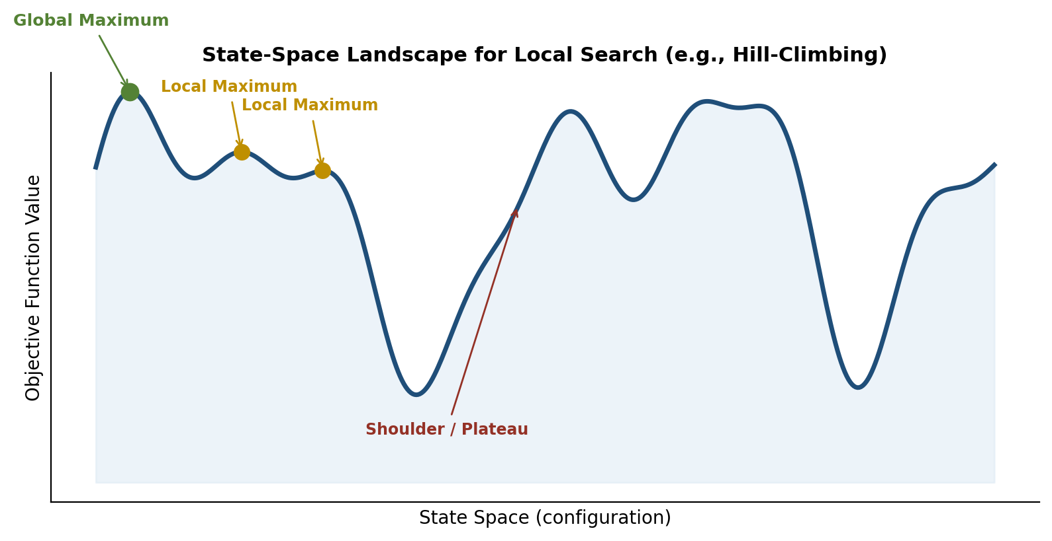
Fig 6.1: State-space landscape illustrating local search
- Hill-Climbing: Repeatedly moves to the neighboring state with the highest value of the objective function ('steepest ascent'), stopping when no neighbor is better. It is simple and memory-efficient but can get stuck at local maxima, plateaus, or ridges, as shown in the landscape diagram above.
- Simulated Annealing: Similar to hill-climbing, but occasionally allows moves to worse states with a probability that decreases over time (controlled by a 'temperature' schedule), enabling escape from local maxima; with a sufficiently slow cooling schedule it converges to the global optimum with probability approaching 1.
- Local Beam Search: Maintains k current states simultaneously (rather than one) and expands all their neighbors, keeping the best k overall, which shares information across the parallel searches unlike running k independent hill-climbs.
- Genetic Algorithms: Maintain a population of candidate states ('individuals'), combining pairs via crossover and applying random mutation, then selecting the fittest individuals (according to the objective/fitness function) to survive into the next generation, mimicking natural selection to search large state spaces.
Applications of local search include the N-Queens problem, VLSI circuit layout, job-shop scheduling, network optimization, portfolio and resource allocation, and hyperparameter tuning in machine learning — cases where the goal is to find a high-quality (not necessarily perfect) configuration among an enormous number of possibilities, and where systematic search would be computationally infeasible.
7. Discuss local search in continuous spaces with suitable examples.
Many real-world optimization problems have continuous state spaces — for example, the location of an airport terminal, or the weights of a neural network — where the number of possible states is infinite, so standard discrete local search techniques (which enumerate discrete neighbors) cannot be applied directly. Local search must instead be adapted using techniques from continuous optimization.
- Discretization: The continuous space can be discretized into a fine grid, and standard hill-climbing or simulated annealing applied over grid points, though this can miss fine detail or become intractable in high dimensions.
- Gradient Ascent/Descent: If the objective function f is differentiable, the gradient (vector of partial derivatives) indicates the direction of steepest increase; the state is updated as x <- x + alpha * grad-f(x), where alpha is a step size, repeated until the gradient is near zero (a local optimum).
- Newton–Raphson Method: Uses both the gradient and the Hessian (second-derivative matrix) to take more informed steps toward a stationary point, often converging faster than plain gradient ascent, at the cost of computing second derivatives.
- Stochastic Gradient methods: Used when the true gradient is expensive to compute exactly (e.g., over large datasets); an approximate gradient from a sample (or mini-batch) is used at each step, common in training machine learning models.
A classic example is optimally placing three new airports to minimize the total distance from a set of existing cities: the state is a set of three (x, y) coordinates, and the objective function is the sum of distances from each city to its nearest airport. Gradient-based local search iteratively adjusts the airport coordinates in the direction that reduces total distance, converging to a locally optimal placement — illustrating how continuous local search replaces discrete 'neighbor generation' with calculus-based direction-finding.
8. Explain how search can be performed when actions are nondeterministic.
When actions are nondeterministic, the outcome of performing an action in a given state is not a single guaranteed resulting state but a set of possible resulting states, because the environment may behave unpredictably (e.g., a vacuum robot's 'suck' action might sometimes fail to pick up dirt, or a wheel might slip during 'move forward'). In such cases, the agent cannot compute a single fixed sequence of actions in advance and simply execute it, because it cannot know which outcome will actually occur.
Instead, the agent must construct a contingency plan (also called an AND-OR plan), which specifies what action to take in every possible situation that could arise. This is represented using an AND-OR search tree: OR nodes represent points where the agent chooses which action to take (as in normal search), while AND nodes represent points where the environment 'chooses' the outcome, and the plan must work for every possible environment outcome branching from that node — hence the agent's plan must succeed across all AND branches.
The AND-OR search algorithm recursively searches this tree: for an OR node, it succeeds if any one action leads to a subplan that succeeds; for an AND node, it succeeds only if a subplan exists that succeeds for every possible outcome. The resulting solution is not a simple sequence but a conditional plan of the form 'if outcome A occurs, do X; if outcome B occurs, do Y,' allowing the agent to adapt its behaviour based on what actually happens after each action — for example, an erratic vacuum-cleaning agent's plan might specify 'suck; if still dirty, suck again' to handle the possibility that the first suck action fails.
9. Discuss search techniques for problems involving partial observations.
In partially observable environments, the agent's sensors do not reveal the complete state of the world, so the agent cannot always know exactly which state it is in. To handle this, the agent reasons in terms of a belief state — the set of all actual world states that are consistent with everything the agent has perceived so far — rather than a single known state.
Sensorless (conformant) search is the extreme case where the agent receives no percepts at all. Here, the agent must find a sequence of actions that achieves the goal regardless of which actual state it started in, by searching over belief states in belief-state space, where each 'state' in this new search problem is itself a set of possible physical states, and each action maps a belief state to a new belief state by applying the transition model to every state within it.
Search with partial observations (contingency search) is a middle case: the agent receives percepts that narrow down (but do not fully resolve) the belief state after each action. The agent must search over belief states while accounting for the fact that different percepts can split one belief state into multiple possible successor belief states (since two initially indistinguishable physical states might yield different percepts once an action is performed), requiring an AND-OR search similar to the nondeterministic case: OR nodes for action choice, AND nodes for each distinguishable percept the agent might receive after acting.
A common example is the vacuum-world sensorless/partially observable variant: without any sensors, the agent does not know which of several possible dirt/location configurations it is in, so it must find an action sequence (e.g., 'move left; suck; move right; suck') guaranteed to clean the floor from every possible initial configuration in its belief state; with partial sensing (e.g., a dirt sensor at the current location only), it can use each percept to shrink its belief state and choose more targeted subsequent actions.
10. Explain online search agents and discuss how they operate in unknown environments.
An online search agent operates by interleaving computation and action in the real environment: rather than computing a complete solution offline (before taking any action, as in standard 'offline' search), it takes an action, observes the actual percept/outcome, and then decides its next action based on this new information. This approach is essential when the environment is unknown (the agent does not have a complete map of states and transitions in advance), when it is dynamic (states can change over time), or when actions are nondeterministic, because in these cases an agent cannot safely commit to and execute a fully pre-computed plan.
A canonical way to implement online search is online depth-first search combined with learning: the agent maintains a table of visited states and explores unvisited actions, backtracking physically (by taking real actions to return to a previous state) rather than just conceptually as in offline DFS, since the agent cannot 'jump' between states in the real world. A more sophisticated method is the Learning Real-Time A* (LRTA*) algorithm, in which the agent maintains and updates estimated cost-to-goal values H(s) for states it has visited, moves to the neighbor with the best current estimate f(s') = c(s,a,s') + H(s'), and updates H(s) for the state it just left based on the actual cost experienced — progressively refining its heuristic estimates as it explores, and guaranteed to eventually find a goal in a safely explorable, finite environment, assuming states are not permanently unrecoverable.
A practical example is a robot exploring an unknown building to find a charging dock: it has no initial map, so it cannot search offline. As it moves (online), it senses which corridors exist and which are dead ends, updates its internal map and cost estimates accordingly, and decides subsequent moves based on this evolving knowledge — trading off exploring unvisited areas (to build better information) against moving toward areas already believed to be promising, until it locates the goal. The key trade-off in online search is between competitive ratio (how much worse the online agent's total cost is compared to an agent that knew the environment in advance) and the unavoidable cost of exploration in an initially unknown world.

